Mobile Computing Class Project Final Report

CSCI 4500/6970 Mobile Computing Fall 2020

# Introduce your UI Design and describe your UI elements (e.g., the functions of every button, etc.)

I used 6 Scenes in Main.Storyboard and 1 Launch Screen scene in Launchscreen.Storyboard to create an IOS application.

* **The 6 Scenes in Main.Storyboard are mentioned below:**
  + First Scene is **Navigation Controller**
  + Second Scene is **Tab Bar Controller**
  + Third Scene is **Browser Scene** with Movie year and genre search
  + Fourth scene is **Search Movies** Scene with Movie title, Movie Type and Movie Year Search
  + Fifth Scene is Search **Genre Result Scene** (When the Search button in the Genre search is selected after the input given will direct to this scene. This Scene shows the movie info such as Movie Name, Year, Image)
  + Sixth Scene is **Search Movie Result Scene** (When the Search button in the Search Movie Scene with the given inputs such as Movie Title, Movie Type or Movie Year will direct to this scene. This scene shows the movie info such as Movie Name, Year, Image and link)
* **UI Elements:**

As they navigate their way around – think buttons, scrollbars, menu items and checkboxes User Interface (UI) were used. TO add interactivity to a user interface, providing touchpoints for the user while they navigate their way.

I Used the below UI Elements in our Application:

* + UIText Field: UI element that enables the app to get user input
  + UILabel: Used for displaying static content.
  + UIView: UIView provides a structure for drawing, laying out sub views, and handling events within a rectangular region of its parent in the view hierarchy.
  + UINavigationBar: Contains the navigation buttons.
  + UINavigationItem: To be represented on the navigation bar, a navigation item must have a title.
  + UIButton: Used for handling user actions.
  + UIImageView: Used to display a simple image or sequence of images.
  + UIScrollView: Used to display content that is more than the area of screen.
  + WKWebView: Displays embedded web content and enables content navigation.
  + UIPickerView: It can be used to make a selection from multiple choices (similar to what a dropdown does for a webpage).
  + CocoaPods: CocoaPods manages library dependencies for your XCode projects. The dependencies for your projects are specified in a single text file called a Podfile. CocoaPods will resolve dependencies between libraries, fetch the resulting source code, then link it together in an XCode workspace to build your project.
  + IQKeyboardManagerSwift: Often while developing an app, we ran into an issue where the iPhone keyboard slides up and cover the UITextField/UITextView. IQKeyboardManager allows you to prevent issues of the keyboard sliding up and cover UITextField/UITextView without needing you to enter any code and no additional setup required. To use IQKeyboardManager you simply need to add source files to your project.

# Introduce your design of mobile application, e.g., MVC models, UML diagrams, etc.

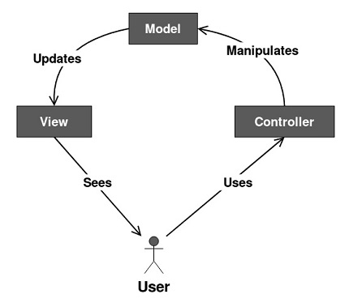

# Please attach your design of the UI (Hand-drawn sketch or Wireframe) along with this report. (You do not need to copy it here.)

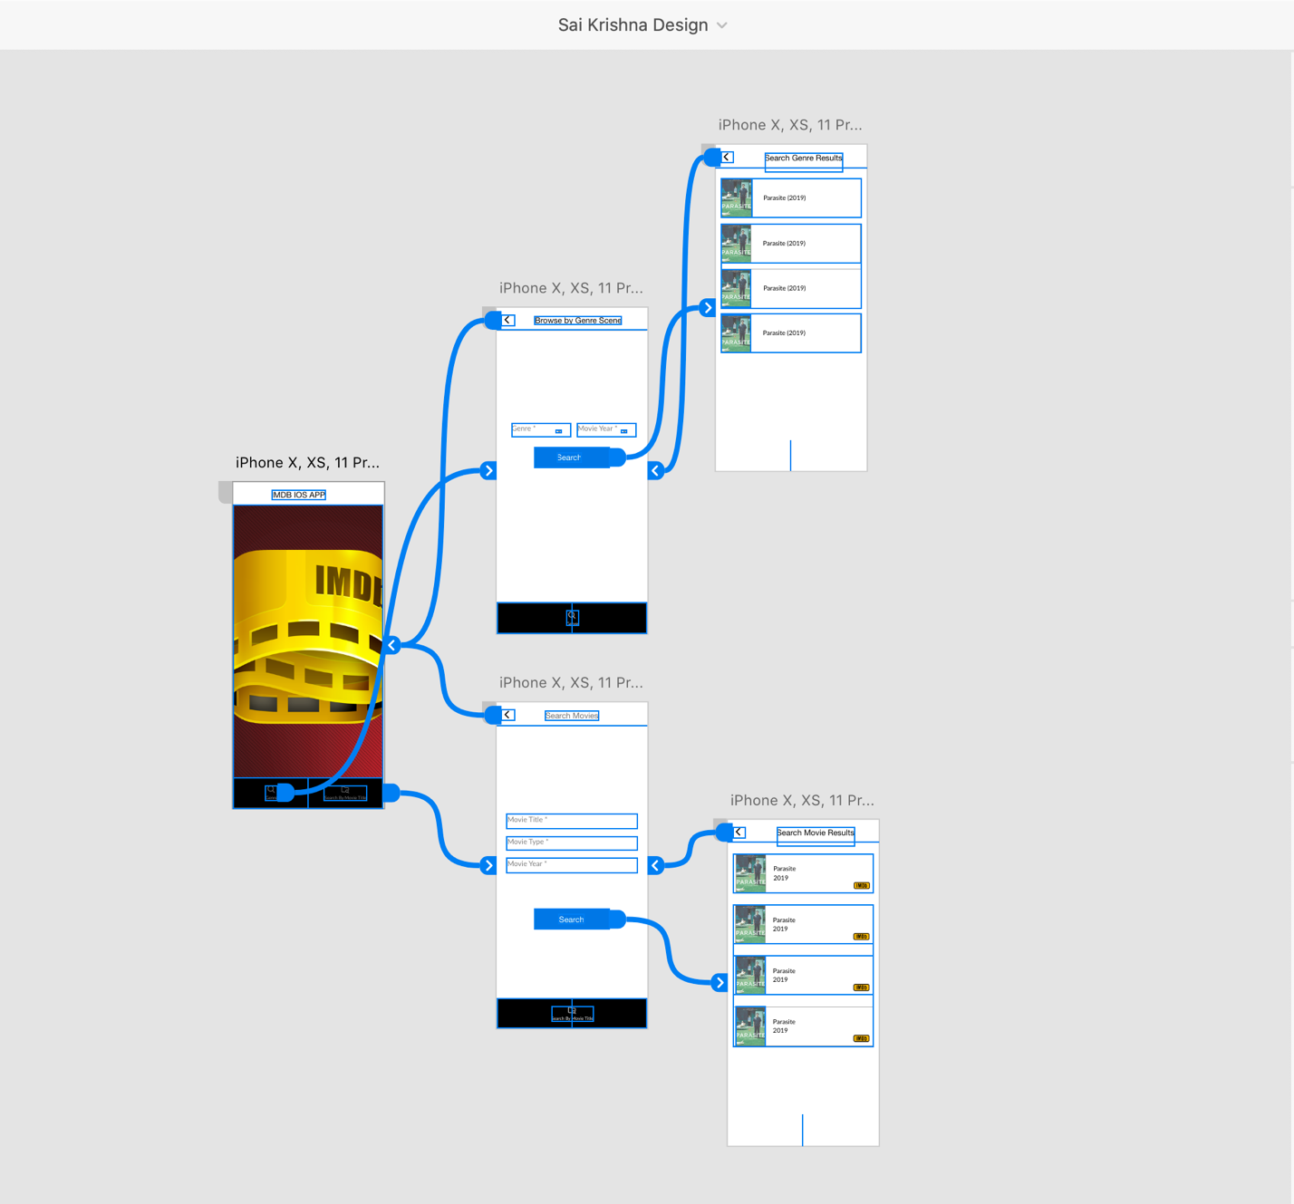

# Please attach your codes (application) or a GitHub link to your project along with this report. (You do not need to copy it here.)

<https://github.com/sai-krishn/Mobile-Computing-Class-Project>

# Input/Output (take screenshots from your apps)

1. Screenshot of browse by genre

In this page we can search movies by the genre and the movie year and by clicking on the search button we will move on to the next page which is in the below screenshot.

1. Screenshots of search genre result

In this page we will get the list of movies that we searched from the above screenshot.

1. Screenshot of search movies

in this page we can search the movie name and we can add the year of the movie and also, we can search by movie type.

By giving the required details we can click the search button and we will go to the next page which is in the below screenshot.

1. Screenshot of search movie result

In this page we will get the result of the screenshot c where we can find all the movies that we have given.

1. Screenshot of imdb link :

We can see a imdb button in the above screenshot and by clicking the button we will get this information of the desired movie in the web.

